practice guide
Family-led decision making

Key concepts

Practice approach
The term ‘family-led decision making’, sometimes referred to as FLDM, is used to describe a practice approach where the family are supported to take the lead in making decisions and taking action to meet the safety, belonging and wellbeing needs of the child or young person. It has been developed from the New Zealand model of Family Group Conferencing. Family-led decision making is the practice approach to be used in Family Group Meetings (FGMs) and other family meetings across the child protection continuum.

Family-led decision making principles and values
Family-led decision making is based on a number of key principles and values:
- Families are the experts in their own lives. Family choice and self-determination is essential.
- Given the opportunity and the right support, families are competent and capable of developing plans and taking action to resolve danger, reduce risk and meet the care and protective needs of their children.
- Participation, collaboration and inclusion are essential to develop and implement safe, positive and sustainable outcomes for children.
- Holding values such as cultural integrity, fairness and curiosity at the forefront supports family-led decision making.
- Strengths based and solution focussed approaches create better processes and outcomes for families and children.

Aboriginal and Torres Strait Islander family-led decision making principles
Aboriginal and Torres Strait Islander family-led decision making includes the above principles of family-led decision making and the following additional principles:
- the process is facilitated by an Aboriginal or Torres Strait Islander person
- the facilitator is employed by an Aboriginal and Torres Strait islander community controlled organisation or is a private convenor
- the meeting is run in an Aboriginal or Torres Strait Islander way
- there is a focus on:
  - creating a culturally safe space
  - mapping kinship networks

Family-led decision making programs
There are essentially three pathways (or programs) for family-led decision making processes, facilitated by:
- the Child Safety Service Centre (CSSC)
- the Collaborative Family Decision Making team (CFDM)
and
- the Family Participation Program (FPP).

Regardless of whether a family-led decision making process is facilitated by the CSSC, CFDM or FPP, the same practice principles apply. While all the programs are based in family-led decision making principles, there are also important differences in each. When considering which program is best suited for a family, the family should be given choice as much as possible.

Consider:
- the working relationship between the family and Child Safety, and between participants
- input from stakeholders and the safety and support network
- complexities in the family dynamics or concerns that may benefit from an independent or more specialised facilitation approach
- cultural safety, connection and participation
- whether the meeting is a FGM under the Child Protection Act 1999
- whether the meeting is for the development of an initial case plan
- whether the matter is before the Children’s Court.

Child Safety Service Centre family-led decision making
Family-led decision making may be facilitated by CSSC staff. If the meeting is an FGM it must be convened by a CSO, senior team leader or senior practitioner who hold delegation as convenors under the Act. It is important for the integrity of the family-led decision making process that the convenor is independent to the decision making, therefore, it is preferable that whoever convenes the meeting is not the decision maker (holding case responsibility).

Even so, this type of family-led decision making provides the least independent process. In some situations, this may still be the most appropriate approach (for example - case plan reviews, or safety planning). However, in other situations, an independent convenor may be a more appropriate and effective option.

Collaborative Family Decision Making team family-led decision making
Collaborative family decision making (CFDM) regional or district teams were established within Child Safety to allow for an increased level of:
- independence of family group meeting convenors (FGMCs)
- specialised supervision
- support.

FGMCs report to principal team leaders (PTLs) outside of the CSSC. FGMCs offer specialised facilitation for family-led decision making processes, independent of CSSCs, providing more options for families.

CFDM teams are also able to engage private convenors to facilitate family-led decision making processes. This provides an additional level of independence compared to the FGMCs who are Child Safety staff.

Family Participation Program Aboriginal and Torres Strait Islander family-led decision making
Family Participation Programs are led by Aboriginal community controlled organisations that are specifically funded and trained (accredited) to facilitate family-led decision making processes with Aboriginal and Torres Strait Islander families. The FPP provide an independent family-led decision making process, delivered by Aboriginal or Torres Strait Islander facilitators.

Family-led decision making meetings
Family-led decision making meetings (family meetings) all involve similar approaches. The meeting process involves:
- referral and planning
- preparation
- facilitation of the meetings, including private family time
- recording and endorsing the plan.

FGMs are prescribed under the Child Protection Act 1999. FGMs are held once a child is in need of protection and there is ongoing intervention. When an FGM is required, the legislative requirements set out in the Act must be followed. These requirements are related to timeliness, information sharing, process and participation. See practice guide Family group meeting legislative requirements for more information.

Family-led decision making documents and plans
With the support of the convenor, the family will capture or record the plan that they developed through the meeting process. This is referred to as the family’s plan. This is the plan that the family develop in relation to the worries and the agreed actions to meet the child’s safety, belonging and wellbeing needs.

The type of documents and plans that are created through this process are dependent on the purpose of the meeting, and the point at which it occurs across the continuum. When a child is in need of protection and requires a case plan, the family’s plan is the basis of the case plan. A CSSC staff member participates in the meeting, and they work together with the convenor and the family to make sure that legislative requirements of the plan are met and the plan satisfies bottom lines for safety. For Aboriginal and Torres Strait Islander children, their cultural support plan also directs and shapes the case plan.

The family may also develop other plans, for example, a safety and support plan, or other agreements that respond to the child’s safety, belonging and wellbeing needs. Once a family has a plan developed, it is used to inform Child Safety’s actions and the supports they implement for the family.

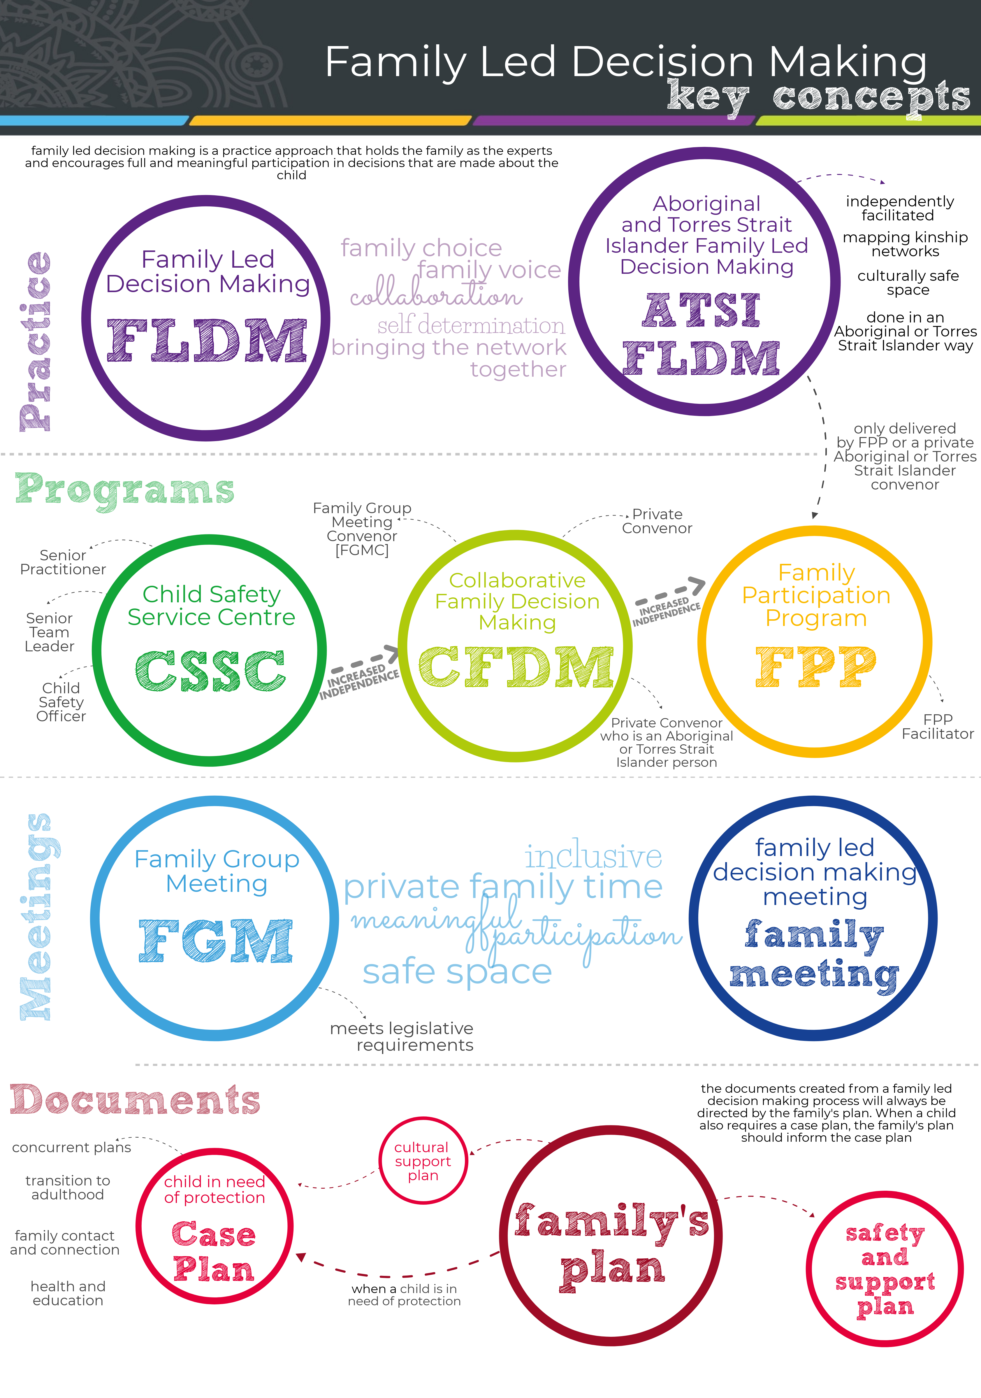

Version history

Published on: | 13 April 2020
Last reviewed: | 09 April 2020

